**Topic 2**

**Related Course Topic: Government and the Economy**

Over the past 50 years, the living standards of people around the world have greatly improved. When people have enough food and enough thick clothes to use, they can gradually focus on spiritual development, education becomes a top priority. In the process of global industrialization, economic growth is proportional to people’s skills, and people learn skills through education. Global technological innovation has made people more aware of the importance of education (Ashton & Green 1996). This article mainly analyzes the average length of schooling of women in developed countries (such as the United States) and developing countries (such as Afghanistan) from the 1970s to the present and analyzes the reasons for this phenomenon and what the countries need to improve in the future.

Around 1980s in Afghanistan, only 14.08% of women graduated from elementary school and 97.21% of females over 15 had no education.There was a war going on because of various political and religious factors in Afghan (Taylor 2014). Afghanistan spent a lot of money on the war, and its citizens’ living standards fell sharply. People worried about what would happen to their country, worried about the food and their life. Naturally, people could not have the energy to think about the education of their children and their individuals (Jones 2007). And due to the war, the country had a shortage of teachers and schools, and even if the child insisted on studying every day, the whole country did not have a complete education system, the child had a hard future. And due to some historical reasons, Afghanistan people prefer boys to girls, so even if there were several learning opportunities, parents would choose to let the boys to study. In Afghanistan’s fragile environment, education is entangled in a complex political economy, making it difficult to ensure the quality of education and its role in society (Pherali & Sahar 2018). So less than 3% of female over 15 years were educated. In the U.S., in the 1980s, the percentage of American women with education reached 48.77 percent, only 1.38% female over 15 years had no education. The United States was able to run its own economy, and when the country had enough food and money, people began to think about the spiritual and the technological development of industrialization (Pherali & Sahar 2018). And the rate of female education in the United States was much higher than in Afghanistan, it means that the number of female who had education in America were much more than Afghanistan. America invested more money to develop education, which is beneficial to the future development of the whole country. So the GDP in Afghanistan was $3.6417 billion and American was $2.8573 trillion.

Four decades later, the percentage of Afghanistan women graduating from primary school has risen to 39.30%, and the percentage of women over age 15 with no education has fallen to 78.24%. Nearly a quarter of women are starting to receive education. And the percentage of American female graduating from elementary school has risen to 48.94%, only increased by 0.17%. And only 0.35% of female over age 15 with no education. Although the education rate of women in Afghanistan today is still lower than that of the United States 40 years ago, the growth rate in Afghanistan is 179%, while the growth rate in the United States is less than 1%. Afghanistan, as a traditional country has always faced many obstacles in terms of the education of women. Despite the efforts made by the education sector in the past few years, the data show that the situation of women’s education is still lamentable (Shayan 2015). Shayan (2015) explained that the status of women in Afghanistan is so low that many girls get married and have children very early, and some parents object the girls to go out to study for some religious reasons, and some girls from poor families need to drop out of school early to work and earn money to support their families, and there are also some girls live in remote areas who are forced to drop out of school because there is no school nearby their home. So how to ensure the education level of female is still a major problem that the Afghanistan government needs to face. On the other hand, the United States, although the U.S. economy is already very good, the percentage of American women who are educated still does not exceed 50%, and now most successful people whether in politics or in business are still men. Jacobs (1996) pointed out that some women may focus on romance when they are growing up. So these will cause them to stay away from studies and careers. Overall, however, the education of men and women in the United States is basically equal.

However, America still needs to pays attention to investment in education, because for the current economic situation, it wants to improve, and it needs to innovation. However, knowledge is outdated faster than before, so people need to keep learning (Moe & Chubb 2009). However, for the Afghanistan government, there is still a lot to do on the road to education reform (Roof 2014). Roof (2014) explained that the government needs to vigorously promote education, so that everyone understands the importance of education and takes the initiative to receive education and take the initiative to learn. At the same time, the government also needs to minimize the influence of religious and history and other reasons in order to increase the awareness of equality between men and women. Government can invest more money in education, such as building more schools in remote areas, and to reduce the average cost of education for people, so that both poor and rich families can let their children receive education.

In conclusion, although the level of GDP and women’s education in the U.S. is much higher than that in Afghanistan, the U.S. government still needs universal education. On the contrary, the Afghan government needs to invest a lot of time and money in education to improve the education level of its citizens. Education is closely related to a country’s economy, so regardless of whether the country’s economy is strong or not, education should be emphasized.

**References**

Ashton, D & Green, F 1996, ‘Education, training and the global economy’ (p. 18). *Cheltenham: E. Elgar.*

Jacobs, J.A 1996, ‘Gender inequality and higher education’, *Annual review of sociology*, *22*(1), pp.153-185.

Jones, A.M 2007, ‘Muslim and western influences on school curriculum in post-war Afghanistan’, *Asia Pacific Journal of Education*, *27*(1), pp.27-40.

Moe, T.M & Chubb, J.E 2009, ‘Liberating learning: Technology, politics, and the future of American education’, *John Wiley and Sons.*

Pherali, T & Sahar, A 2018, ‘Learning in the chaos: A political economy analysis of education in Afghanistan’, *Research in Comparative and International Education*, *13*(2), pp.239-258.

Roof, D.J 2014, ‘Day-by-day: Higher education in Afghanista’, In *FIRE: Forum for International Research in Education* (Vol. 1, No. 3, p. 6).

Shayan, Z 2015, ‘Gender inequality in education in Afghanistan: Access and barriers’, *Open Journal of Philosophy*, *5*(05), p.277.

Taylor, N 2014, ‘The Soviet War in Afghanistan, 1979-1989’, *The Atlantic*, viewed 4 August 2014, http://www.theatlantic.com/photo/2014/08/the-soviet-war-in-afghanistan-1979-1989/100786/

**Appendix**

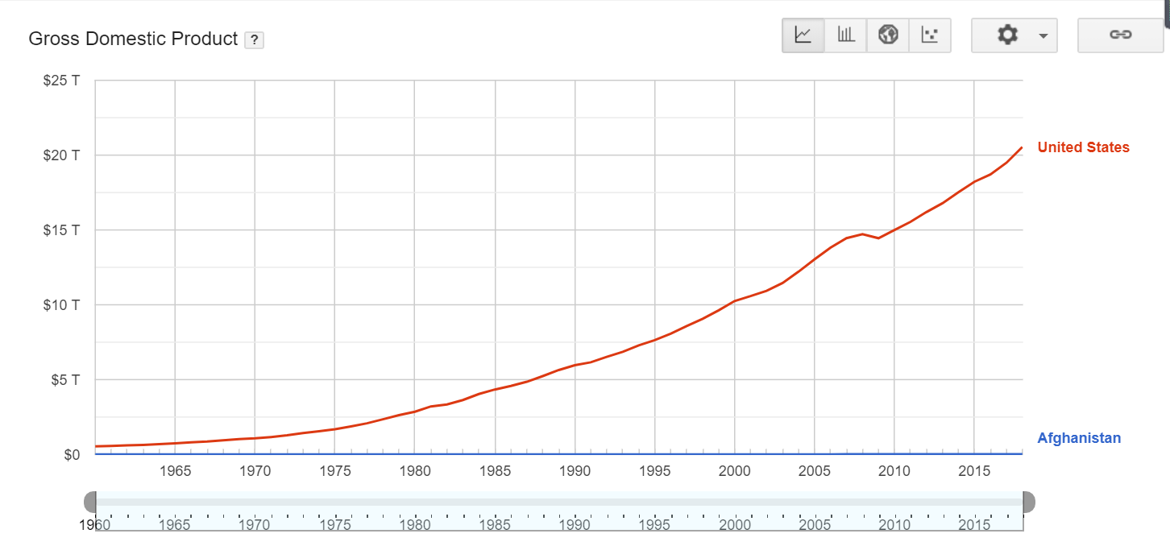

(source from World Bank)

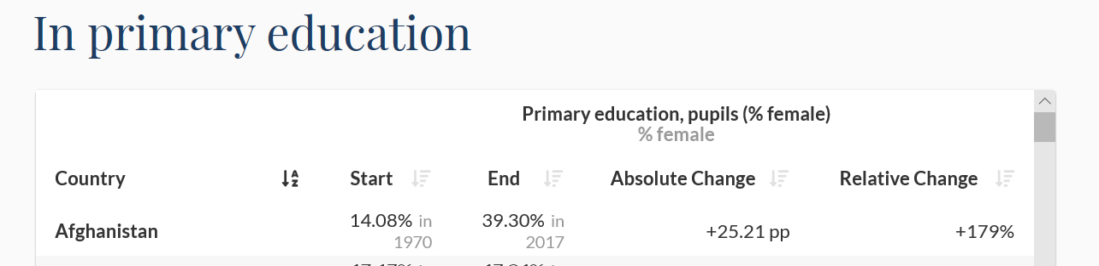



(source from World Bank – World Development Indicators)

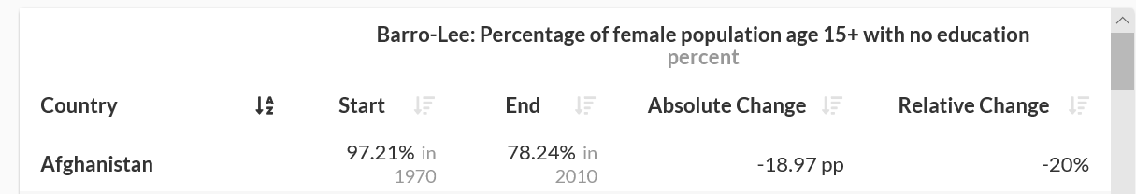



(source from World Bank – World Development Indicators)